Name: Vincenzo Jason Carter  
NIM : 2702242700

**EXPLANATION OF EACH PAGE (Sinefolis Cinemas)**

**Home.html**

This page serves as the main landing page for Sinefolis Cinemas. It aims to welcome users, showcase current highlights, and provide easy navigation to other parts of the site.

* **Hero Section & Carousel:**
* **References :**<https://i.pinimg.com/736x/45/f3/75/45f375c06efde0a1153fd326e29606e1.jpg>

<https://i.pinimg.com/736x/45/fe/69/45fe69527d057e7979cde79e151302ef.jpg>  
<https://i.pinimg.com/736x/5b/75/ae/5b75ae548cd82c012692108b3e007b2b.jpg>

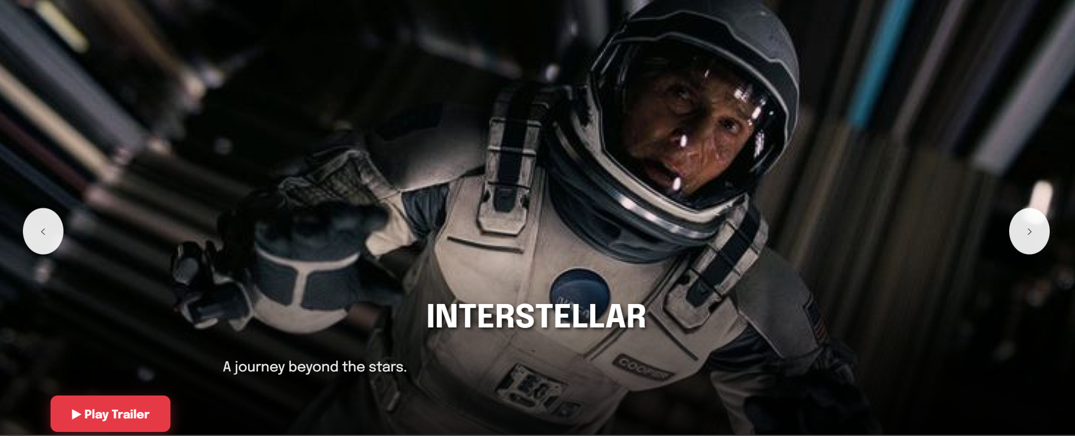

* + This section immediately greets the user with a large, dynamic image carousel.
  + The carousel displays featured movie promotions, cycling through different items. Each item in the carousel includes a background image, a movie title, a brief description, and a "Watch Trailer" button.
  + The content for these carousel captions (title, description, trailer link) is dynamically loaded from ../../data/carousel_data.json by fetchCarouselCaption.js. The carousel's sliding functionality and controls (next/prev buttons) are managed by carousel.js.
  + Styling for the carousel, including its dimensions, caption overlays, and buttons, is handled by home.css.
* **Cinema Features Showcase:**

**References :**

<https://i.pinimg.com/736x/4c/ab/90/4cab90273958b5f0caa1b2d1d93763d7.jpg>   
<https://www.google.com/imgres?q=4dx%20cinema%20logo&imgurl=https%3A%2F%2Fcdn.celluloidjunkie.com%2Fwp-content%2Fuploads%2F2024%2F04%2F16061345%2F4DX-Logo-Premium-Black-1.png&imgrefurl=https%3A%2F%2Fcelluloidjunkie.com%2Fwire%2Fcj-4dplex-and-palace-amusement-to-launch-first-ever-4dx-theater-in-jamaica%2F&docid=m512-gL16CEGsM&tbnid=rW1Sr5AdYcYPGM&vet=12ahUKEwi9-uDMxrGNAxUS9qACHZyLO1YQM3oFCIIBEAA..i&w=2092&h=841&hcb=2&ved=2ahUKEwi9-uDMxrGNAxUS9qACHZyLO1YQM3oFCIIBEAA>

<https://www.google.com/imgres?q=3d%20cinema%20logo&imgurl=https%3A%2F%2Fimg.favpng.com%2F10%2F2%2F15%2F3d-film-cinema-logo-png-favpng-mXgKiChU0egiekEKvJRq36FpP.jpg&imgrefurl=https%3A%2F%2Ffavpng.com%2Fpng_view%2Fsymbol-3d-film-cinema-logo-png%2F4XRhjRh0&docid=sGjT6-mLmacSrM&tbnid=oaxW37vU1D6ZmM&vet=12ahUKEwj4yr7n7LGNAxVjnmMGHQtSAAsQM3oECBgQAA..i&w=820&h=512&hcb=2&ved=2ahUKEwj4yr7n7LGNAxVjnmMGHQtSAAsQM3oECBgQAA>

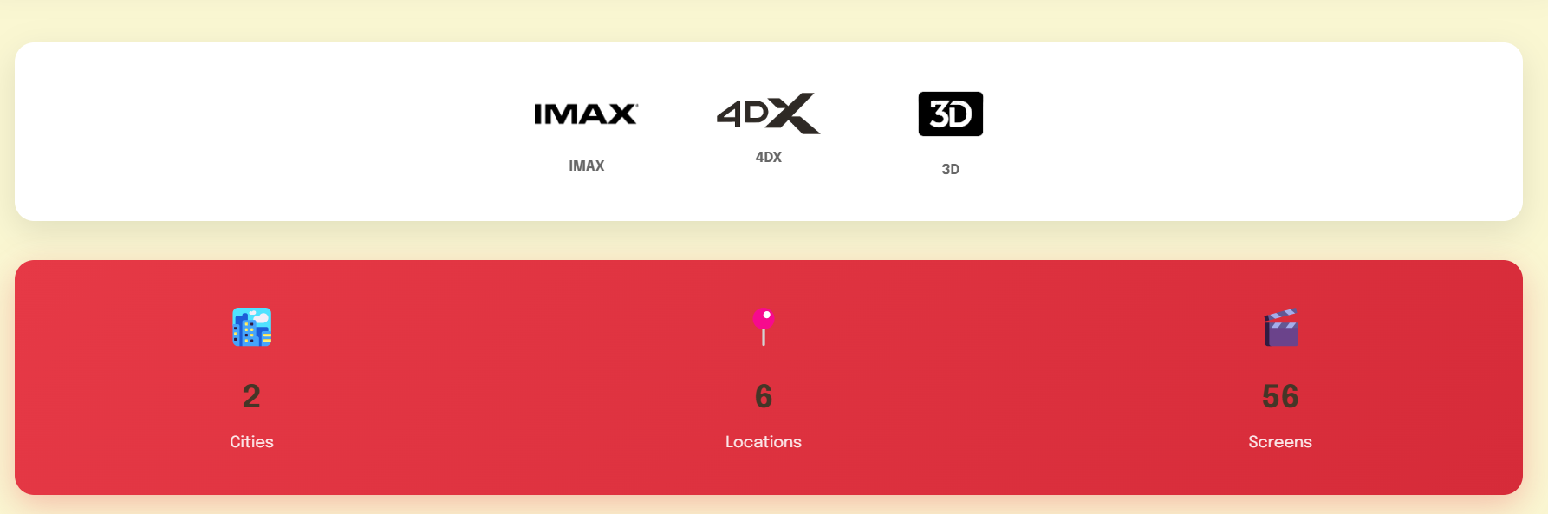

* + Below the hero carousel, this area highlights the cinema's technological offerings.
  + It displays logos for IMAX, 4DX, and 3D experiences, each with a corresponding label.
  + Further down, a section visually presents statistics such as the number of cities, locations, and screens Sinefolis Cinemas operates in. This section uses icons and bold numbers for impact.
* **Welcome Text:**



* + A prominent "Welcome to Sinefolis Cinemas" heading and a tagline are displayed to reinforce the brand and user entry point.
* **"NOW SHOWING" Section:**

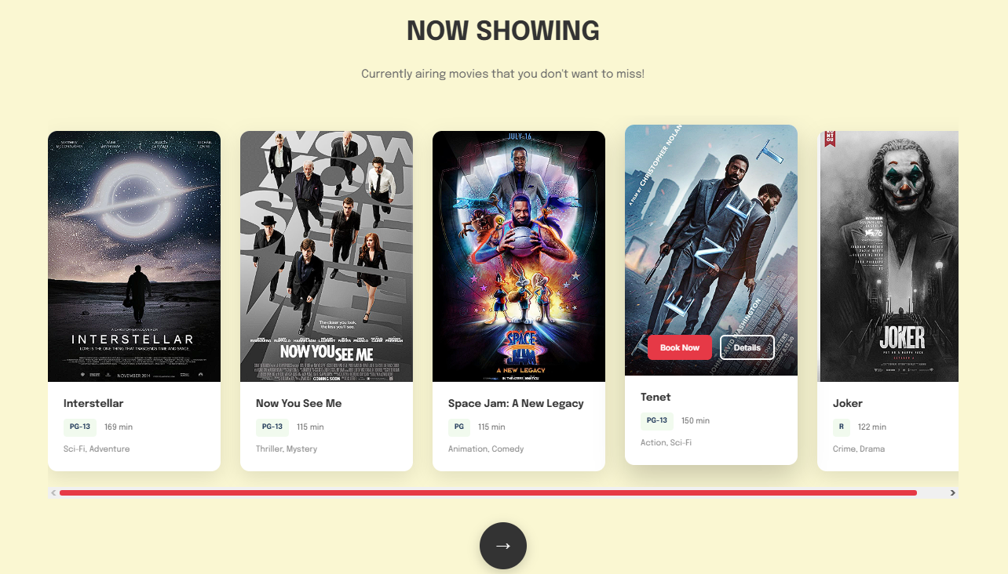

* + This section is titled "NOW SHOWING" and presents a horizontally scrollable grid of movies currently playing.
  + Each movie is displayed as a card (.movie-card) showing its poster, title, rating (e.g., PG-13), duration, and genre.
  + When a user hovers over a movie card, an overlay appears with "Book Now" and "Details" buttons.
  + The "Book Now" button is scripted to navigate to nowshowing.html and trigger a modal for that specific movie (e.g., MapsTo('nowshowing.html?showModalForMovie=interstellar')). The MapsTo function itself is likely provided by loader.js.
  + The "Details" button navigates to movie_details.html with the movie's ID as a query parameter.
  + A "View All Movies" arrow button at the end of the grid links to the main nowshowing.html page.
* **"UPCOMING MOVIES" Section:**

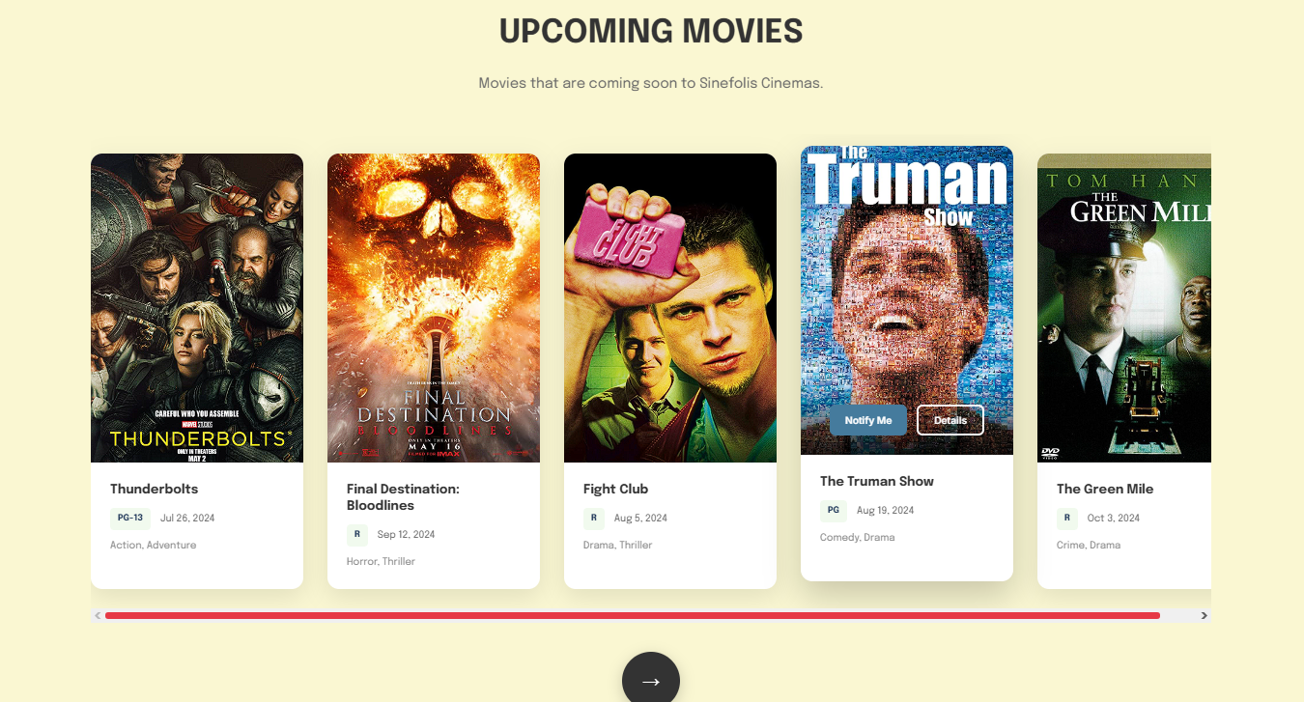

* + Similar in layout to the "Now Showing" section, this part lists movies that are coming soon.
  + Movie cards display poster, title, rating, release date, and genre.
  + The overlay buttons are "Notify Me" and "Details". "Details" would link to movie_details.html (or upcoming_details.html).
  + A "View All Upcoming" arrow button links to the upcoming section of nowshowing.html (nowshowing.html#upcoming).
* **"TOP USED PROMOS" Section:**

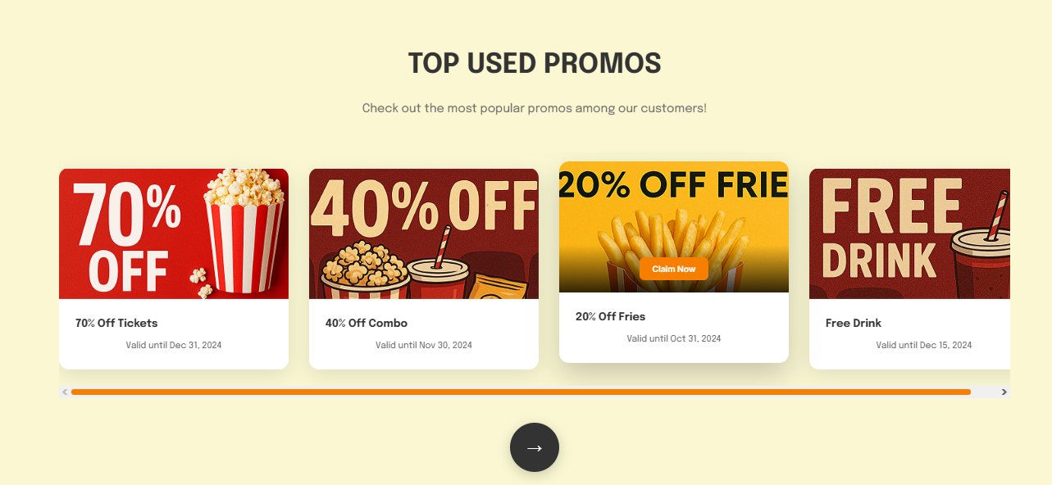

* + This section showcases popular promotional offers in a scrollable grid.
  + Each promo card (.promo-card) displays an image, title, validity information, and an overlay "Claim Now" button.
  + Clicking a promo card navigates to promo_details.html with the promo's ID.
  + An arrow button links to the main promo.html page.
* **General Page Behavior:**
  + Many sections on the homepage utilize the .fade class, which, in conjunction with fade.js and global.css, creates a fade-in effect as users scroll down the page.
  + The overall page structure is defined in home.html.
  + Base styling is provided by global.css, with page-specific enhancements in home.css.
  + The common navbar and footer are loaded dynamically by navbar.js (fetching components/navbar.html) and footer.js (fetching components/footer.html) respectively.
  + The page loader animation is handled by loader.js.

**Promo.html (Promos Page)**

This page is dedicated to showcasing all available promotions and deals offered by Sinefolis Cinemas.

References :  
<https://i.pinimg.com/736x/7b/cb/47/7bcb472e34c433b612a1f40d769306a2.jpg>

<https://i.pinimg.com/736x/08/bd/a6/08bda649dbb5aeede7d44c2f4fc09c7f.jpg>

<https://i.pinimg.com/736x/e9/7c/37/e97c37166e06e49c0d1239ca17b32720.jpg>

<https://i.pinimg.com/736x/32/05/a5/3205a5165ee4a083ab665500e109c952.jpg>

<https://i.pinimg.com/736x/1d/4d/4e/1d4d4e57b266410bd652df6323eb4f36.jpg>

<https://i.pinimg.com/736x/08/37/8a/08378a7e7c208268b71f886c8e8ee3d0.jpg>

<https://i.pinimg.com/736x/fa/00/51/fa005168ce4850e0a0c5a697447d44ef.jpg>

<https://i.pinimg.com/736x/36/d3/10/36d310b5e084ee15c481ca6958a376b3.jpg>

<https://i.pinimg.com/736x/10/10/81/1010814f4d4fba21e9a05c3b2c70166b.jpg>

* **Promotional Banner Carousel:**

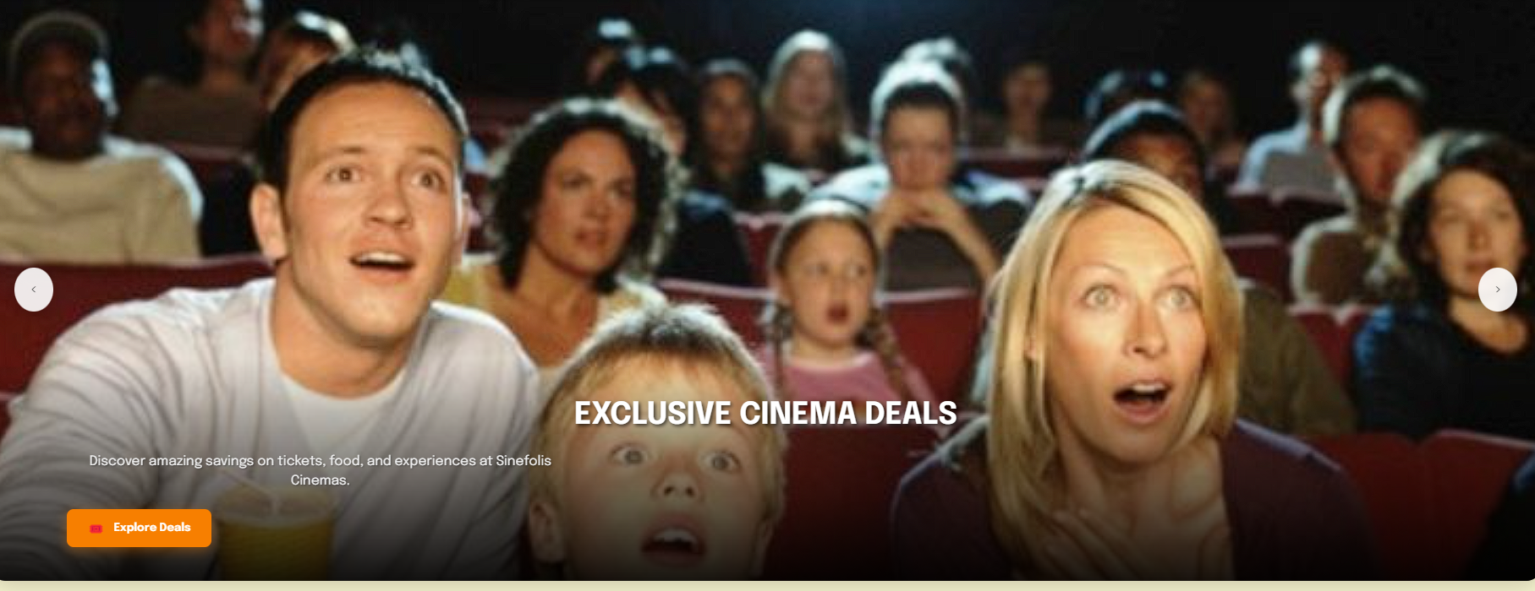

* + The top of the page features a large, attention-grabbing image carousel, similar in function to the one on the homepage.
  + This carousel displays various promotional banners with titles, descriptions, and "Explore Deals" / "Learn More" / "View Offers" buttons.
  + The carousel functionality is managed by carousel.js. Dynamic content for the banner captions is intended to be loaded by fetchPromoBanner.js (though the script itself wasn't provided, it's linked in promo.html).
  + Styling for this banner is defined in promo.css.
* **Hero Text Section:**



* + Below the banner, a section with the title "Step Into the Spotlight of Savings" and a descriptive tagline sets the theme for the page.
* **Categorized Promo Listings:**

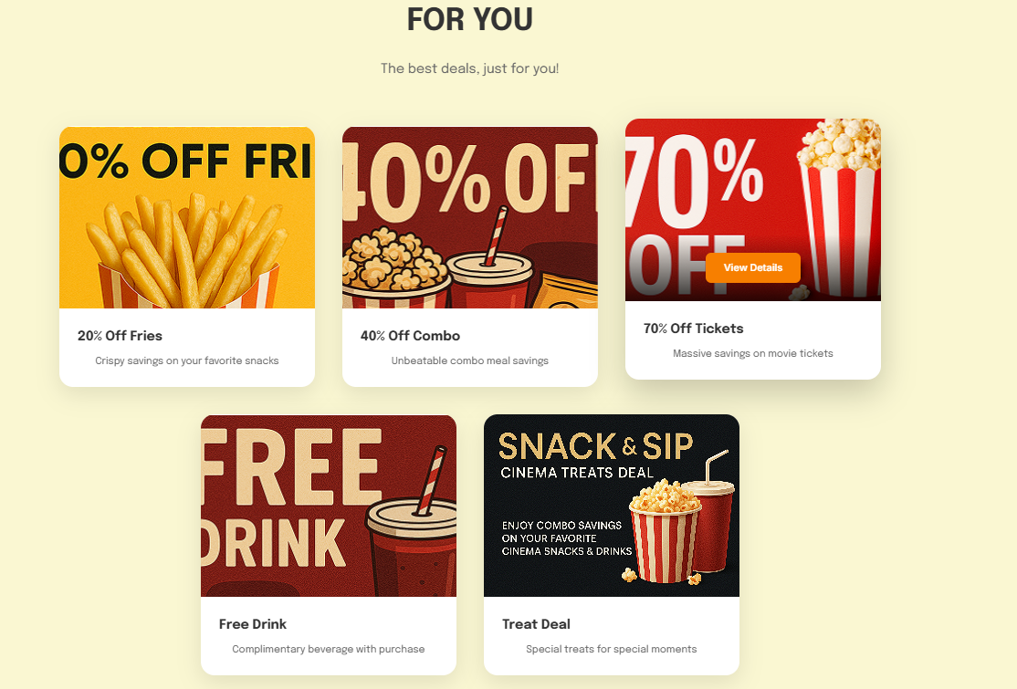

* + The main content area is divided into themed sections to organize promotions:
    - **"FOR YOU":** Displays general deals considered relevant to the user.
    - **"FILM FESTIVAL 2025":** Showcases offers specifically related to an annual film festival.
    - **"LOVEBIRD DISCOUNTS":** Features promotions tailored for couples.
  + Each section (.promo-section) has a header and a grid of promo cards (.top_promos, .film_festival, .lovebirds).
  + Promo cards typically include an image, a title, a brief description, and an overlay "View Details" button. Some cards in the "FILM FESTIVAL" and "LOVEBIRD DISCOUNTS" sections also have prominent text overlays (e.g., "20% OFF", "BUY 1 GET 1") directly on the image.

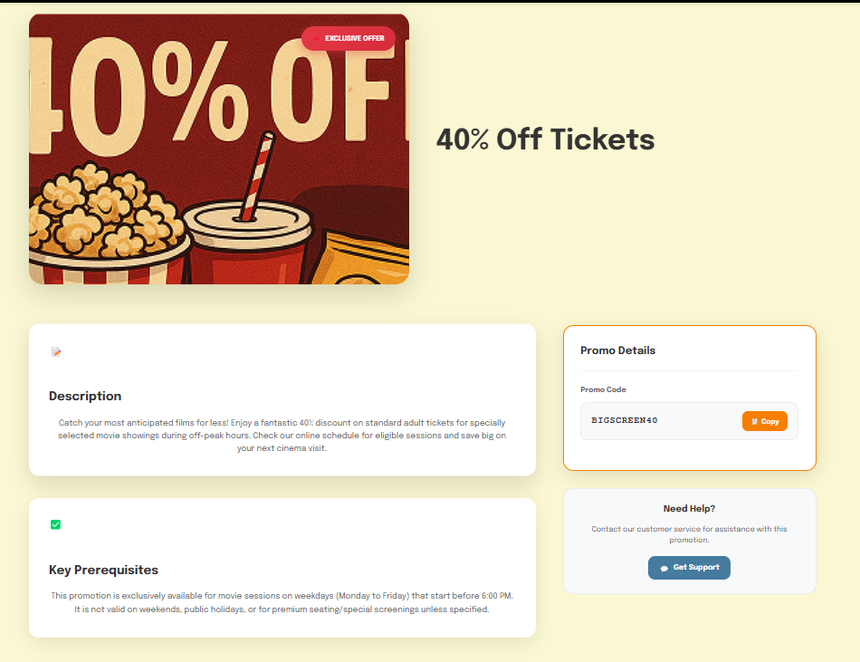

* + Clicking on any promo card or its "View Details" button navigates the user to promo_details.html, passing the specific promo's ID as a URL parameter (e.g., MapsTo('promo_details.html?id=20offfries')).
* **General Page Behavior:**
  + The layout is defined in promo.html.
  + Styling comes from global.css for common elements and promo.css for page-specific looks, including the promo card designs and section layouts.
  + The navbar and footer are loaded by navbar.js and footer.js.
  + Page transitions are managed by loader.js.
  + Sections marked with .fade utilize fade.js for animations on scroll.
  + The promo card details are currently static in promo.html, but they link to promo_details.html which loads data dynamically.

**Nowshowing.html (Movies Page)**

This page serves as the central hub for Browse both currently playing and upcoming movies at Sinefolis Cinemas.

**References:**

* Now Showing Movies

<https://i.pinimg.com/736x/2a/b5/14/2ab51409bf2df8b4b42078cb31ff9e1f.jpg>

<https://i.pinimg.com/736x/bd/fe/b1/bdfeb147efed7da7b560ea42607bd7ef.jpg>

<https://i.pinimg.com/736x/8d/63/c6/8d63c64a05ef324a96574f9127c44625.jpg>

<https://i.pinimg.com/736x/f0/0e/f4/f00ef4ef28062a3ffe32c80cfa039c86.jpg>  
<https://i.pinimg.com/736x/71/02/cd/7102cdb6d5d68bff1034facbc1da6ede.jpg>  
<https://i.pinimg.com/736x/03/98/f1/0398f1de4cd31ef5bfe3529898030dcc.jpg>  
<https://i.pinimg.com/736x/e3/bf/9e/e3bf9e04cc68a7229019cf6db6b93c7e.jpg>  
<https://i.pinimg.com/736x/bd/fb/17/bdfb17d46a8c819414ce227c7df38c8c.jpg>

<https://i.pinimg.com/736x/13/25/13/1325138d5ed981d60b0bd637aa97178c.jpg>  
<https://i.pinimg.com/736x/6b/9c/b4/6b9cb41b100cfca5bfda6bbdc67845c6.jpg>

<https://i.pinimg.com/736x/1e/af/9a/1eaf9a8d4d580f286cb2d7a3405abf74.jpg>  
<https://i.pinimg.com/736x/99/a7/2d/99a72ddea619733a659e093b95cea0b7.jpg>

* Upcoming Movies

<https://i.pinimg.com/736x/1c/71/34/1c713456da884b80b34b7440af1f369f.jpg>  
<https://i.pinimg.com/736x/ee/1d/1f/ee1d1fa01dd074649fc7270055a1cc90.jpg>  
<https://i.pinimg.com/736x/29/a4/da/29a4da565e04e1a2d8fc459e1996f229.jpg>  
<https://i.pinimg.com/736x/e9/6a/d1/e96ad125bf0fad17202acd4501ffb41e.jpg>  
<https://i.pinimg.com/736x/ca/1d/78/ca1d78a293fd9b959bb6b3d58d55faaf.jpg>  
<https://i.pinimg.com/736x/b7/95/44/b795447414c34b18eddc91fdea0fffef.jpg>  
<https://i.pinimg.com/736x/17/58/e8/1758e820d84675aa8a2435d12b44df59.jpg>  
<https://i.pinimg.com/736x/0a/04/0c/0a040ca43c20cea8f5b0ca48e89df57a.jpg>  
<https://i.pinimg.com/736x/82/3f/c2/823fc28eabcf4d30e200d672032d3e8d.jpg>  
<https://i.pinimg.com/736x/bc/af/43/bcaf4391b6cfc77a74ede9536e411c36.jpg>  
<https://i.pinimg.com/736x/41/e0/f6/41e0f614e2eeae226117267f18e7ac47.jpg>  
<https://i.pinimg.com/736x/bd/45/3c/bd453c9a65afc9cc0bcaafd2eb730d25.jpg>

* Assets for Booking

<https://www.vecteezy.com/png/34968551-ai-generated-popcorn-tub-clip-art>  
<https://www.google.com/url?sa=i&url=https%3A%2F%2Fpngtree.com%2Ffreepng%2Fnachos-with-cheese-dipping-sauce_16747521.html&psig=AOvVaw2rqbwNY468Ce1UDBFuxztv&ust=1748745133306000&source=images&cd=vfe&opi=89978449&ved=2ahUKEwi1oYe11cyNAxVc1jgGHdyZFZkQjRx6BAgAEBk>  
<https://www.google.com/url?sa=i&url=https%3A%2F%2Fwww.vecteezy.com%2Fpng%2F46542660-a-pile-of-colorful-candy-on-a-transparent-background&psig=AOvVaw11Kzz8aCHrYKGkvWxMVDip&ust=1748745238115000&source=images&cd=vfe&opi=89978449&ved=0CBEQjRxqFwoTCPiswOfVzI0DFQAAAAAdAAAAABAE>

<https://www.google.com/url?sa=i&url=https%3A%2F%2Fid.pngtree.com%2Fso%2Fhot-dog&psig=AOvVaw0VqZdptNzbnfw6i0vUq8yD&ust=1748745351423000&source=images&cd=vfe&opi=89978449&ved=0CBEQjRxqFwoTCJiErZ_WzI0DFQAAAAAdAAAAABAE>  
<https://www.citypng.com/photo/bc09a2a6/cocacola-old-can-cold-soda-drink>  
<https://www.citypng.com/photo/13622/hd-bottled-of-mineral-water-with-glass-illustration-png>  
<https://www.citypng.com/photo/1773607d/glass-of-red-cranberry-fruit-juice>  
<https://www.google.com/url?sa=i&url=https%3A%2F%2Fwww.vecteezy.com%2Ffree-png%2Fpopcorn-and-drink&psig=AOvVaw0Dnos5vQE51SOORK0fSSdt&ust=1748746930234000&source=images&cd=vfe&opi=89978449&ved=0CBEQjRxqFwoTCKDX1dzczI0DFQAAAAAdAAAAABAE>

<https://www.google.com/url?sa=i&url=https%3A%2F%2Fid.pngtree.com%2Fso%2Fpopcorn-film&psig=AOvVaw0bSAAzYX6rMTPZGE2jihMF&ust=1748747019744000&source=images&cd=vfe&opi=89978449&ved=0CBEQjRxqFwoTCOiznsbczI0DFQAAAAAdAAAAABAE>

* **Tabbed Interface ("Now Showing" / "Upcoming"):**
  + The page features two main tabs, "Now Showing" and "Upcoming," allowing users to switch between these views.
  + This tab functionality is controlled by nowshowing.js, which updates the active button and displays the corresponding movie section (#nowShowingSection or #upcomingSection). The URL hash is updated accordingly (#now-showing or #upcoming).
* **Dynamic Movie Grids:**
  + **Now Showing:** When this tab is active, nowshowing.js fetches data from ../../data/movies.json (for general movie details) and ../../data/booking_info.json (for showtime availability). It then dynamically generates and displays movie cards for films that have current showtimes.
  + **Upcoming:** When this tab is active, nowshowing.js fetches data from ../../data/upcoming_movies.json and populates the grid with upcoming movies.
  + Each grid (.movies-grid) displays movies as cards (.movie-card).
* **Movie Card Features:**
  + Each movie card shows a poster, title, rating, duration (for now showing) or release info (for upcoming), and genre.
  + **Now Showing Cards:** Feature "Book Now" and "Details" buttons in an overlay.
  + **Upcoming Cards:** Feature "Notify Me" and "Details" buttons in an overlay.
* **Showtime Modal Functionality:**
  + Clicking the "Book Now" button (class .btn-book or .dynamic-btn-show-schedule) on a "Now Showing" movie card triggers a modal (#showtimeModal).
  + nowshowing.js populates this modal with the movie's title and a list of available showtimes, categorized by date, theater name, and screen name/format, using data from currentBookingInfo (loaded from booking_info.json).
  + Each showtime slot is a clickable button. Clicking a specific showtime button in the modal calls goToBookingPage() to navigate the user to booking.html with the selected movie ID, date, and showtime index as URL parameters.
  + The modal can be closed using an 'X' button or by clicking outside its content area.
  + The page can also open directly with the showtime modal displayed if the showModalForMovie URL parameter is present.
* **Navigation from Cards:**
  + "Details" buttons on both "Now Showing" and "Upcoming" cards navigate to the respective movie detail pages (movie_details.html or upcoming_details.html) with the movie's ID.
  + "Notify Me" buttons on "Upcoming" cards navigate to notify.html with the movie's ID (functionality for actual notification sign-up relies on notify.js, which wasn't provided).
* **General Page Behavior:**
  + The base structure is in nowshowing.html.
  + Styling is provided by global.css and nowshowing.css (which includes styles for the tabs, movie grid, cards, and the showtime modal).
  + Common components (navbar, footer, loader) and fade animations are handled by their respective JavaScript files (navbar.js, footer.js, loader.js, fade.js).

**Cinemas.html (Cinemas Page)**

This page provides users with information about the physical locations of Sinefolis Cinemas.

**References :**<https://www.google.com/imgres?q=grand%20indonesia&imgurl=https%3A%2F%2Fupload.wikimedia.org%2Fwikipedia%2Fcommons%2Fd%2Fd7%2FGrand_Indonesia_Mall.jpg&imgrefurl=https%3A%2F%2Fid.wikipedia.org%2Fwiki%2FGrand_Indonesia&docid=bKq8P8dGhcqTGM&tbnid=bLJ91TnuTt5nVM&vet=12ahUKEwi5kpL6n9ONAxUD4zgGHR0YHp8QM3oECBgQAA..i&w=4000&h=3000&hcb=2&ved=2ahUKEwi5kpL6n9ONAxUD4zgGHR0YHp8QM3oECBgQAA>  
<https://www.google.com/imgres?q=pondok%20indah%20mall&imgurl=https%3A%2F%2Fdynamic-media-cdn.tripadvisor.com%2Fmedia%2Fphoto-o%2F2e%2F17%2F2a%2F05%2Fpim.jpg%3Fw%3D1200%26h%3D1200%26s%3D1&imgrefurl=https%3A%2F%2Fwww.tripadvisor.co.id%2FAttraction_Review-g294229-d3844446-Reviews-or10-Pondok_Indah_Mall-Jakarta_Java.html&docid=UBQcFAgBk0nWSM&tbnid=8tN4m9ixKv55BM&vet=12ahUKEwiO_ufWoNONAxVCumMGHVYhEQIQM3oECGUQAA..i&w=1200&h=960&hcb=2&ved=2ahUKEwiO_ufWoNONAxVCumMGHVYhEQIQM3oECGUQAA>  
<https://www.google.com/url?sa=i&url=https%3A%2F%2Falamat.co.id%2Fmall%2Fmall-kelapa-gading-13249.html&psig=AOvVaw0riGUUgtptPCwNV3vBgJsB&ust=1748971545719000&source=images&cd=vfe&opi=89978449&ved=2ahUKEwi8pvTuoNONAxXjzjgGHS-1JQoQjRx6BAgAEBk>  
<https://www.google.com/imgres?q=tunjungan%20plaza&imgurl=https%3A%2F%2Ftunjunganplaza.com%2Fassets%2Ffile%2Ftp%2Fanchor-home%2Flarge%2Fparallax-bg-tunjunganplaza.jpg&imgrefurl=https%3A%2F%2Ftunjunganplaza.com%2F&docid=viO8D_T8WTWu5M&tbnid=y1S_CE5TtoqNhM&vet=12ahUKEwjrut76odONAxXeS2wGHbtJMCQQM3oECB0QAA..i&w=1200&h=712&hcb=2&ved=2ahUKEwjrut76odONAxXeS2wGHbtJMCQQM3oECB0QAA>  
  
<https://www.google.com/imgres?q=galaxy%20mall%20surabaya&imgurl=https%3A%2F%2Fupload.wikimedia.org%2Fwikipedia%2Fcommons%2Fe%2Fe8%2FGalaxy_Mall%252C_Surabaya.jpg&imgrefurl=https%3A%2F%2Fid.wikipedia.org%2Fwiki%2FGalaxy_Mall&docid=etp8TPxEboWVVM&tbnid=-WRC10Rwg-F9IM&vet=12ahUKEwiTlZmUotONAxUYTWwGHegZGdAQM3oECBgQAA..i&w=1229&h=922&hcb=2&ved=2ahUKEwiTlZmUotONAxUYTWwGHegZGdAQM3oECBgQAA>  
<https://www.google.com/imgres?q=pakuwon%20mall%20surabaya&imgurl=https%3A%2F%2Fasset.kompas.com%2Fcrops%2FrqNK74NCWPBa10iF9KOpugrj_wA%3D%2F186x0%3A1806x1080%2F1200x800%2Fdata%2Fphoto%2F2021%2F12%2F05%2F61ac5f23d81c5.jpg&imgrefurl=https%3A%2F%2Fwww.kompas.com%2Fproperti%2Fread%2F2021%2F12%2F05%2F153649721%2Fpakuwon-mall-surabaya-pusat-belanja-terluas-di-indonesia%3Fpage%3Dall&docid=0Vqc_hC-G6RHvM&tbnid=thQ8dfzCZoURJM&vet=12ahUKEwiMyZDgotONAxWKbmwGHX3wBKoQM3oECBYQAA..i&w=1200&h=800&hcb=2&ved=2ahUKEwiMyZDgotONAxWKbmwGHX3wBKoQM3oECBYQAA>  
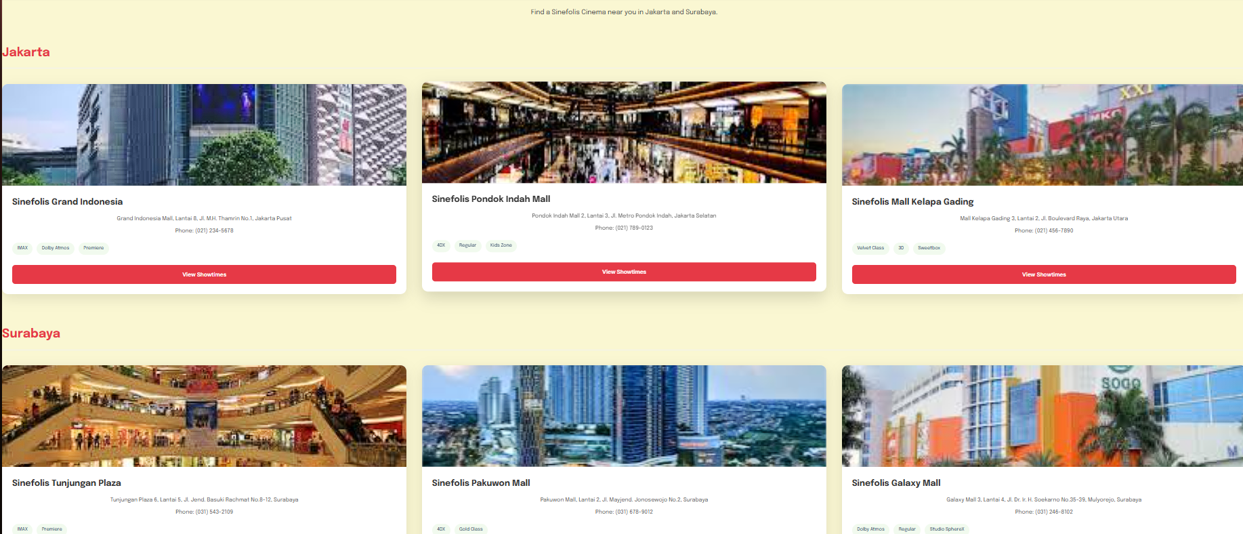

* **Page Header:**
  + The page starts with a title "Our Cinemas" and a subtitle guiding users to find nearby locations.
* **Cinema Listings by City:**
  + Cinema locations are grouped under city headings, such as "Jakarta" and "Surabaya".
  + Each city section (.city-section) displays its cinemas in a grid layout (.cinemas-grid).
* **Cinema Card Details:**
  + Each cinema is represented by a .cinema-card.
  + Each card includes:
    - A placeholder for a map image (.cinema-map-placeholder), which currently uses static images from the ../../assets/locations/ directory.
    - Cinema name (.cinema-name), full address (.cinema-address), and phone number (.cinema-phone).
    - A list of amenities available at that location (e.g., "IMAX", "Dolby Atmos", "Premiere"), displayed as tags (.amenity-tag).
    - A "View Showtimes" button (.btn-view-showtimes) that navigates the user to the nowshowing.html page, allowing them to see movies playing.
* **Construction Details:**
  + **HTML File:** cinemas.html is the main file containing the structure for this page. All cinema data is currently hardcoded into this file.
  + **Key HTML Structure:**
    - <header class="page-header-cinemas"> for the main title.
    - <section class="city-section"> for each city, containing a <div class="cinemas-grid">.
    - Individual locations are presented in <div class="cinema-card">.
  + **CSS Styling:**
    - global.css provides foundational styles.
    - cinemas.css styles the page-specific elements like the header, city section titles, the grid layout, and the appearance of individual cinema cards including their map placeholders, textual information, amenity tags, and the "View Showtimes" button.
  + **JavaScript Logic & Interactivity:**
    - navbar.js and footer.js load the common header and footer components.
    - loader.js handles page loading animations.
    - fade.js is linked and would apply fade-in animations if the .fade class were used on sections (it's not explicitly shown in the main content of the provided cinemas.html).
    - cinemas.js includes a simple function to scroll to a section if its ID is present in the URL hash (e.g., cinemas.html#jakartaCinemas). It also defensively defines a MapsTo function if one isn't already global.
    - The "View Showtimes" buttons use an inline onclick="navigateTo('nowshowing.html')" for navigation.
  + **Data Source (if any):** None for the main content. All cinema details are static within cinemas.html.
  + **How it Works Together:** cinemas.html defines the structure and content for listing cinema locations. cinemas.css controls the visual presentation. Minimal JavaScript in cinemas.js aids with potential deep linking via URL hashes. Standard JS modules handle the navbar, footer, and loader.

**Feedback.html (Feedback Page)**

This page allows users to submit their feedback to Sinefolis Cinemas by filling out a structured form.

* **Page Introduction:**
  + The page displays a welcoming header "We Value Your Feedback!" and a short paragraph encouraging users to share their thoughts.
* **Feedback Form (#feedbackForm):**
  + The core of the page is a comprehensive form enabling users to provide various details. The form includes the following fields:
    - **Full Name:** A text input (<input type="text" id="fullName">).
    - **Email Address:** An email input (<input type="email" id="email">).
    - **Phone Number:** A telephone input (<input type="tel" id="phone">), marked as optional.
    - **Feedback Type:** A dropdown/select menu (<select id="feedbackType">) allowing users to categorize their feedback (e.g., Compliment, Complaint, Suggestion, Question).
    - **Your Feedback:** A multiline text area (<textarea id="feedbackMessage">) for the main feedback content.
    - **Overall Experience Rating:** A group of radio buttons (<input type="radio" name="rating">) for users to select a rating from 1 to 5.
  + Each form field is accompanied by a <label> and a <small class="error-message"> element, which is used by JavaScript to display validation errors.
  + A "Submit Feedback" button triggers the form submission process.
  + A div with id="formSubmissionStatus" is used to display overall success or error messages after a submission attempt.
* **Client-Side Validation (JavaScript-based, No Regex):**
  + The feedback.js script handles all client-side validation when the form is submitted.
  + It checks for:
    - **Required Fields:** Ensures Full Name, Email, Feedback Type, Feedback Message, and Rating are not empty.
    - **Minimum Length:** Validates that Full Name is at least 3 characters and Feedback Message is at least 10 characters.
    - **Email Format:** Performs a basic check for a valid email structure (presence and basic positioning of "@" and ".") without using regular expressions.
    - **Phone Number Format:** If a phone number is entered, it checks if it contains only digits and falls within a length range (7-15 digits).
    - **Select & Radio Validation:** Ensures a valid option is chosen from the Feedback Type dropdown (not the default placeholder) and that a rating radio button is selected.
  + If validation fails, error messages are displayed next to the respective fields.
  + If validation passes, a success message is shown, and the form is cleared. Note: The provided feedback.js simulates submission and does not send data to a backend server.
* **Construction Details:**
  + **HTML File:** feedback.html defines the form structure.
  + **CSS Styling:**
    - global.css provides base styling for common elements.
    - feedback.css contains specific styles for the feedback page layout, the form container (.feedback-container), form groups (.form-group), labels, input fields, select dropdown, textarea, radio button group (.rating-group), error messages, submission status messages, and the submit button.
  + **JavaScript Logic & Interactivity:**
    - navbar.js and footer.js load the standard navbar and footer.
    - loader.js manages the page loading animation.
    - feedback.js is the primary script for this page, responsible for attaching event listeners to the form, performing all client-side validations upon submission, and updating the UI with error or success messages.
  + **Data Source (if any):** None. This page is designed for user input and client-side processing of that input.
  + **How it Works Together:** The feedback.html file creates the form interface. feedback.css ensures it's styled consistently and user-friendly, with visual cues for errors. feedback.js adds the interactive validation layer, guiding the user to fill out the form correctly before (simulating) submission, enhancing the user experience by providing immediate feedback without needing a server roundtrip for basic checks.